**Abstract**

The Doctor Appointment System (DAS) represents a pivotal advancement in healthcare administration, catering to the evolving needs of both patients and medical practitioners. By harnessing technological innovation, DAS revolutionizes the traditional appointment scheduling process, offering a centralized platform accessible to all stakeholders. Patients benefit from the convenience of online appointment requests, enabling them to book consultations with preferred doctors at their convenience. Simultaneously, healthcare providers can efficiently manage their schedules, update availability, and optimize patient flow, thereby enhancing overall clinic productivity.

At the heart of the DAS lies its intuitive user interface, designed to streamline the appointment management process with simplicity and clarity. Patients navigate seamlessly through the system to select appointment slots, specify their medical concerns, and receive timely reminders, ensuring optimal attendance rates. Doctors leverage the platform to maintain up-to-date schedules, review patient histories, and allocate sufficient time for consultations, thereby fostering a patient-centric approach to care delivery. Administrative staff harness the system's capabilities to manage patient registrations, handle billing tasks, and generate insightful reports, empowering informed decision-making and resource allocation within the healthcare facility.

Furthermore, the DAS prioritizes data security and privacy, employing robust encryption protocols and access controls to safeguard sensitive patient information. Compliance with regulatory standards such as HIPAA ensures confidentiality and integrity throughout the appointment lifecycle, instilling trust and confidence among patients and healthcare providers alike. As healthcare systems continue to evolve in response to changing societal demands, the Doctor Appointment System stands as a beacon of innovation, heralding a new era of efficiency, accessibility, and patient-centered care delivery.

**Introduction**

The Doctor Appointment System is a web-based application developed to simplify the process of scheduling and managing appointments between doctors and patients. In today's fast-paced world, efficient appointment management is crucial for healthcare providers to ensure smooth operations and optimal patient care. This system aims to address common challenges faced in traditional appointment booking methods by providing an intuitive and user-friendly platform for both patients and doctors.

a hassle-free way for patients to book appointments and for doctors to manage their schedules seamlessly. No more endless phone calls or lost appointment cards. Just a simple, user-friendly system that puts everyone's needs first.

The introduction section of the project report serves as an overview of the system's purpose, significance, and objectives. It outlines the motivation behind developing the system and highlights the key problems it aims to solve. Additionally, it provides a brief overview of the project scope and key features to be discussed in detail throughout the report.

The introduction sets the stage for the reader by providing context and background information about the Doctor Appointment System. It aims to capture the reader's interest and convey the importance of the project in addressing real-world needs within the healthcare industry. Furthermore, it outlines the structure of the report, guiding the reader through the various sections that will be covered in-depth.

**Objective**

Our main objective in developing the Doctor Appointment System is to revolutionize the way appointments are scheduled and managed in healthcare settings. We aim to address the common challenges faced by both patients and doctors in the traditional appointment booking process by providing a modern, efficient, and user-friendly solution.

We strive to simplify the appointment booking process for patients, making it quick and easy to schedule appointments at their convenience. By providing a user-friendly interface and intuitive form, we aim to minimize the time and effort required to secure appointments.

For doctors and healthcare administrators, our objective is to provide a comprehensive platform for managing appointments efficiently. This includes features such as approving or cancelling appointments, viewing appointment details, and generating reports to track appointment statistics.

Another key objective is to increase accessibility to healthcare services by offering an online platform for appointment booking. This allows patients to schedule appointments from anywhere, at any time, without the need for phone calls or in-person visits.

By automating various aspects of the appointment scheduling and management process, our objective is to improve overall efficiency within healthcare practices. This includes reducing administrative workload, minimizing scheduling conflicts, and optimizing resource utilization.

**Need of Doctor Appointment System**

Traditional methods of appointment scheduling often involve lengthy phone calls, manual paperwork, and potential miscommunications. A Doctor Appointment System streamlines this process, allowing patients to book appointments conveniently online, reducing administrative burden and saving time for both patients and healthcare providers.

With the rise of digital technology, patients expect convenient access to healthcare services. A Doctor Appointment System offers round-the-clock accessibility, enabling patients to book appointments from the comfort of their homes using smartphones or computers. This accessibility is particularly beneficial for individuals with mobility issues or busy schedules.

Long waiting times for appointments are a common frustration for patients. By efficiently managing appointment slots and reducing scheduling conflicts, a Doctor Appointment System can help minimize waiting times, leading to improved patient satisfaction and better utilization of healthcare resources.

For healthcare providers, efficient appointment management is essential for optimizing resource utilization and maintaining a smooth workflow. A Doctor Appointment System provides tools for managing appointment schedules, allocating resources effectively, and generating reports to analyse appointment trends and performance metrics.

**Aim and Scope**

**Aim:**

The Doctor Appointment System aims to revolutionize the traditional method of scheduling and managing appointments within healthcare facilities by leveraging cutting-edge technology and innovative design principles. Our primary aim is to create a robust, user-friendly, and efficient platform that enhances the overall patient experience while empowering healthcare providers with tools to optimize appointment management processes.

**Scope:**

1. Appointment Booking:

* The system provides patients with a seamless and intuitive interface for scheduling appointments online. Patients can specify their preferred date, time, and doctor, with the system offering real-time availability updates and suggestions to streamline the booking process. Customizable booking options cater to individual patient preferences and ensure flexibility in appointment scheduling.

1. Appointment Management:

* Healthcare providers benefit from a comprehensive dashboard that centralizes appointment management tasks. Doctors can view their schedule at a glance, manage appointment requests, and make adjustments as needed to accommodate patient needs. Advanced scheduling algorithms optimize appointment slots based on factors such as patient flow, doctor availability, and clinic resources.

1. Doctor Authentication and Authorization:

* Security is paramount in the Doctor Appointment System. Robust authentication mechanisms ensure that only authorized Dcotor gain access to the system, with role-based access controls governing user permissions and actions. Multi-factor authentication adds an extra layer of security, protecting sensitive patient data and maintaining compliance with privacy regulations.

1. Communication:

* Effective communication between patients and healthcare providers is facilitated through various channels within the system. Automated appointment reminders via email or SMS help reduce no-shows and improve patient adherence to appointments. Secure messaging features enable patients to communicate with their doctors, ask questions, and receive timely responses, fostering patient engagement and satisfaction.

1. Data Management:

* The system prioritizes data integrity, confidentiality, and compliance with regulatory standards. Patient information and appointment records are stored securely in a centralized database, with stringent access controls and encryption measures in place to safeguard sensitive data. Regular backups and disaster recovery protocols ensure data resilience and continuity of service.

1. Reporting and Analytics:

* Healthcare providers gain valuable insights into appointment trends, patient demographics, and clinic performance through robust reporting and analytics tools. Customizable reports and dashboards provide actionable data for strategic decision-making, resource allocation, and performance evaluation. Predictive analytics capabilities enable proactive planning and optimization of clinic workflows.

1. Integration with External Systems:

* Seamless integration with external services and systems enhances the functionality and interoperability of the Doctor Appointment System. Integration with payment gateways facilitates secure online transactions for appointment fees, while interoperability with electronic health record (EHR) systems ensures seamless exchange of patient information and streamlines administrative workflows.

1. Scalability and Flexibility:

* The system is designed to scale and adapt to the evolving needs of healthcare facilities of all sizes and specialties. Modular architecture and configurable settings allow for easy customization and adaptation to specific workflows and requirements. Scalable infrastructure and cloud-based deployment options ensure reliability, performance, and scalability to support growing patient volumes and organizational needs.

**Methodology Development Model**

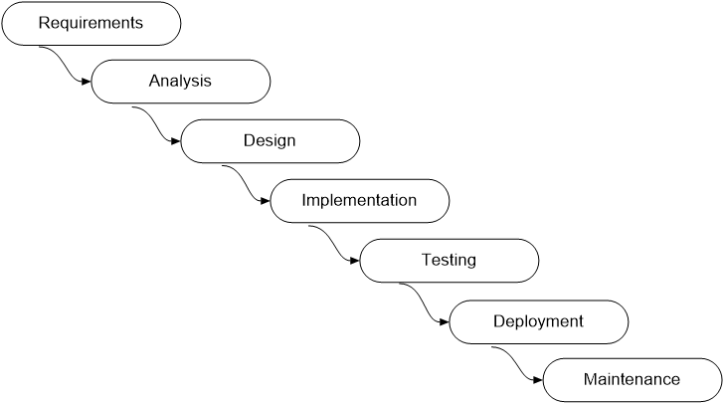

Figure 1 – Waterfall model

* **Requirements Gathering :** In this initial phase, stakeholders collaborate to gather and document the project requirements. This involves identifying the needs and objectives of the project, as well as any constraints or limitations that may impact its development.
* **System Design :** Once the requirements are established, the system architecture and design are developed. This phase focuses on defining the overall structure of the system, including its components, interfaces, and functionality.
* **Implementation :** In the implementation phase, the actual coding and development of the software occur based on the specifications outlined in the design phase. Programmers write code according to the requirements and design documents.
* **Testing :** After the implementation phase, rigorous testing is conducted to identify and rectify any defects or issues in the software. This involves various testing techniques such as unit testing, integration testing, and system testing to ensure the quality and reliability of the software.
* **Deployment :** Once the software has been thoroughly tested and validated, it is deployed to the production environment or released to end-users. This phase involves installing the software, configuring it for use, and providing any necessary training and support.
* **Maintenance:** The final phase of the Waterfall Model involves ongoing maintenance and support of the software. This includes addressing user feedback, fixing bugs, and implementing updates or enhancements to improve the software's performance and functionality.

**Problem Analysis**

1. **Manual Appointment Scheduling:**
   * Many healthcare facilities still rely on manual methods for scheduling appointments, which can be inefficient and prone to errors.
   * Patients often face difficulties in finding available appointment slots and coordinating with doctors' schedules, leading to delays and frustration.
2. **Limited Access to Information:**
   * Patients may have limited access to information about available doctors, their specializations, and appointment availability.
   * Without a centralized system, patients may struggle to make informed decisions about their healthcare needs and preferences.
3. **Appointment Management Challenges:**
   * Doctors and administrative staff may encounter challenges in managing and coordinating appointments, leading to scheduling conflicts and inefficiencies.
   * Without a systematic approach to appointment management, doctors may struggle to optimize their schedules and allocate sufficient time for patient consultations.
4. **Communication Barriers:**
   * Communication barriers between patients, doctors, and administrative staff can hinder the appointment scheduling process.
   * Patients may experience difficulties in reaching healthcare providers to schedule appointments or obtain timely information about their appointments.
5. **Data Management Issues:**
   * Healthcare facilities may face challenges in managing and organizing patient data, appointment records, and doctor schedules effectively.
   * Manual record-keeping processes can result in data inaccuracies, duplication, and difficulty in retrieving information when needed.
6. **Patient Experience and Satisfaction:**
   * The overall patient experience may be negatively impacted by long wait times, scheduling delays, and communication gaps.
   * Unsatisfactory experiences can lead to patient dissatisfaction, reduced loyalty to healthcare providers, and negative word-of-mouth referrals.
7. **Resource Utilization and Efficiency:**
   * Inefficient appointment scheduling and management processes can result in underutilization of healthcare resources and increased operational costs.
   * Optimizing resource allocation and streamlining appointment workflows is essential for maximizing efficiency and improving the quality of patient care.
8. **Scalability and Growth:**
   * As healthcare facilities expand and patient demand increases, scalability becomes a concern.
   * The system should be designed to accommodate growth, supporting a larger number of appointments, users, and healthcare providers without compromising performance or user experience.

**Design Consideration**

1. **User Experience (UX):**

* Prioritize the user experience by focusing on intuitive and user-friendly interfaces. Design interfaces that are easy to navigate and understand, with clear labelling and intuitive controls.
* Conduct user research and usability testing to understand user needs and preferences. Incorporate feedback to refine the design and improve usability.
* Ensure consistency in design elements, such as colour schemes, typography, and layout, to create a cohesive and seamless user experience across the application.

1. **Scalability and Performance:**

* Design the system architecture with scalability in mind to accommodate growth and handle increasing user loads. Use scalable infrastructure and distributed computing techniques to support a large number of concurrent users.
* Optimize database queries and application code to improve performance and reduce latency. Use caching mechanisms to store frequently accessed data and reduce the load on the server.
* Implement load balancing strategies to distribute traffic evenly across multiple servers and prevent bottlenecks. Monitor system performance and scalability regularly and make adjustments as needed to maintain optimal performance.

1. **Security:**

* Implement robust security measures to protect sensitive data and prevent unauthorized access. Use encryption to secure data both at rest and in transit, and implement strong authentication mechanisms to verify user identities.
* Regularly update and patch system components to address security vulnerabilities and protect against potential threats. Conduct regular security audits and penetration testing to identify and mitigate security risks.
* Implement access controls and permissions to restrict access to sensitive information based on user roles and responsibilities. Monitor system activity and implement logging and auditing mechanisms to track and investigate security incidents

1. **Accessibility:**

* Design interfaces that are accessible to users with disabilities, including those with visual, auditory, motor, or cognitive impairments. Follow accessibility standards such as the Web Content Accessibility Guidelines (WCAG) to ensure compliance.
* Provide alternative text for images, captions for videos, and descriptive labels for form fields to assist users who rely on assistive technologies such as screen readers.
* Ensure that the application is navigable using keyboard shortcuts and that interactive elements are usable without a mouse. Allow users to adjust font sizes and contrast settings to accommodate individual preferences.

1. **Compatibility:**

* Test the application across a range of devices, browsers, and screen sizes to ensure compatibility and consistent performance. Address any compatibility issues identified during testing to ensure a seamless user experience across different platforms.
* Use responsive design techniques to adapt the layout and functionality of the application based on the user's device and screen size. Ensure that content is accessible and legible on both desktop and mobile devices.

1. **Modularity and Extensibility:**

* Design the system with a modular architecture to facilitate the integration of new features and functionalities. Use well-defined APIs and service-oriented architecture (SOA) principles to enable seamless communication between different components of the system.
* Implement clear separation of concerns and maintainable code practices to enable easy maintenance and extensibility. Use design patterns such as MVC (Model-View-Controller) to organize code and promote reusability.
* Allow for customization and extension through plugins or modules to meet the evolving needs of users and stakeholders. Provide documentation and developer resources to support the development of customizations and extensions.

1. **Data Integrity and Reliability:**

* Implement data validation and integrity checks to ensure that data is accurate, complete, and consistent. Use validation rules and constraints to enforce data integrity at the database level and prevent data corruption.
* Implement backup and recovery mechanisms to protect against data loss and ensure data availability in the event of system failures or disasters. Regularly backup data and store backups in secure and redundant locations to minimize the risk of data loss.
* Monitor system performance and reliability using monitoring tools and alerts. Implement error handling and recovery mechanisms to detect and recover from failures automatically, minimizing downtime and ensuring uninterrupted service.

1. **Regulatory Compliance:**

* Ensure compliance with relevant regulations and standards, such as HIPAA (Health Insurance Portability and Accountability Act) for healthcare data privacy. Familiarize yourself with the requirements of applicable regulations and implement controls and safeguards to ensure compliance.
* Implement features and controls to support regulatory requirements for data protection, patient confidentiality, and privacy. Use encryption, access controls, and audit trails to protect sensitive data and demonstrate compliance with regulatory requirements.

**Tools And Technologies**

1. HTML
2. CSS
3. JavaScript
4. Php
5. MySql
6. BootStrap
7. JQuery
8. Git
9. Xampp
10. Visual Studio Code
11. **Programming Languages :**

* **HTML/CSS/JavaScript :** These front-end technologies were employed to create the user interface of the system, providing a visually appealing and interactive experience for users.
* **PHP :** PHP (Hypertext Preprocessor) was chosen as the primary programming language for server-side development due to its versatility, robustness, and extensive community support.

1. **Database Management System (DBMS) :**

* **MySQL** : MySQL was utilized as the relational database management system for storing and managing the system's data. Its reliability, performance, and compatibility with PHP make it a popular choice for web-based applications.

1. **Front-End Frameworks/Libraries :**

* **Bootstrap :** Bootstrap was utilized as a front-end framework to facilitate the development of responsive and mobile-friendly user interfaces. Its pre-designed components and grid system expedited the UI design process.
* **jQuery:** jQuery, a fast and feature-rich JavaScript library, was used to simplify client-side scripting and enhance the interactivity of the system's interface.

1. **Version Control :**

* **Git:** Git, a distributed version control system, was employed for collaborative development and version management of the project codebase. It enabled seamless collaboration among team members and facilitated code review and integration.

1. **Development Environment :**

* **XAMPP/WAMP:** XAMPP (cross-platform, Apache, MySQL, PHP, and Perl) or WAMP (Windows, Apache, MySQL, PHP) were used as local development environments to set up a complete web server environment on developers' machines. These tools provided a convenient and standardized environment for testing and debugging the system locally before deployment.

1. **Integrated Development Environment (IDE) :**

* **Visual Studio Code:** Visual Studio Code, a lightweight and feature-rich code editor, was utilized by developers for writing, editing, and debugging code. Its extensive selection of extensions and built-in Git integration enhanced productivity and workflow efficiency.

**Database Design**

1. **tblappointment:**
   * **ID**: Unique identifier for each appointment.
   * **AppointmentNumber**: Unique identifier or code assigned to each appointment.
   * **Name**: Name of the patient who scheduled the appointment.
   * **MobileNumber**: Contact mobile number of the patient.
   * **Email**: Email address of the patient.
   * **AppointmentDate**: Date of the scheduled appointment.
   * **A**ppointmentTime: Time of the scheduled appointment.
   * **Specialization**: The specialization of the doctor for the appointment.
   * **Doctor**: Full name or identifier of the doctor associated with the appointment.
   * **Message**: Additional message or notes provided by the patient while scheduling the appointment.
   * **ApplyDate**: Date when the appointment was scheduled or applied for.
   * **Remark**: Any remarks or comments related to the appointment.
   * **Status**: Status of the appointment (e.g., scheduled, confirmed, canceled).
   * **UpdationDate**: Date and time when the appointment information was last updated.
2. **tbldoctor:**
   * **ID**: Unique identifier for each doctor.
   * **FullName**: Full name of the doctor.
   * **MobileNumber**: Contact mobile number of the doctor.
   * **Email:** Email address of the doctor.
   * **Specialization**: The specialization of the doctor.
   * **Password**: Encrypted password for doctor authentication.
   * **CreationDate**: Date when the doctor's account was created.
   * **AppointmentStatus**: Status of the doctor's appointment availability.

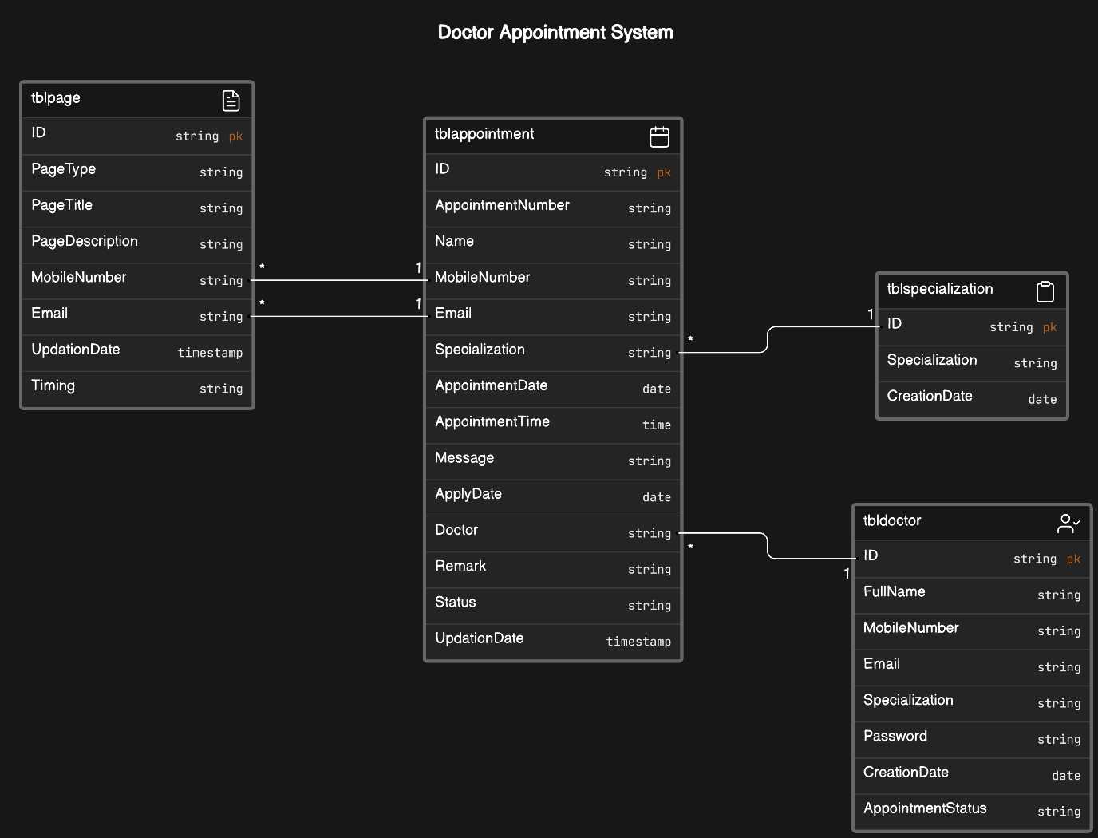

Figure 2 – ERP Diagram

1. **tblpage:**
   * **ID**: Unique identifier for each page.
   * **PageType**: Type or category of the page (e.g., landing page, about page, contact page).
   * **PageTitle**: Title of the page displayed to users.
   * **PageDescription**: Description or content of the page.
   * **Email**: Contact email address associated with the page.
   * **MobileNumber**: Contact mobile number associated with the page.
   * **UpdationDate**: Date and time when the page information was last updated.
   * **Timing**: Timing information related to the page (e.g., opening hours for contact page).
2. **tblspecialization:**
   * **ID**: Unique identifier for each specialization.
   * **Specialization**: Name or category of the specialization (e.g., cardiology, pediatrics, dermatology).
   * **CreationDate**: Date when the specialization record was created.

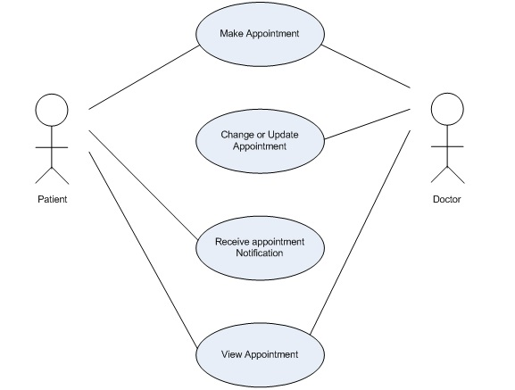

Figure 3 – Use Case Diagram

1. **Users :**
   * **Patients:** Individuals who require medical attention and make appointments with doctors.
   * **Doctors:** Healthcare professionals who provide medical services to patients.
   * **Administrative Staff:** Personnel responsible for managing appointments, patient records, and other administrative tasks.
   * **System Administrators:** Individuals responsible for maintaining and managing the appointment system.
2. **Processes:**

* Appointment Scheduling: Patients request appointments through the system, which are then scheduled based on the availability of doctors and other resources.
* Doctor Availability Management: Doctors update their availability within the system, indicating their working hours, vacation days, and other relevant information.
* Patient Registration: New patients register within the system, providing their personal information, medical history, and insurance details.
* Appointment Reminders: Automated reminders are sent to patients to notify them of upcoming appointments.

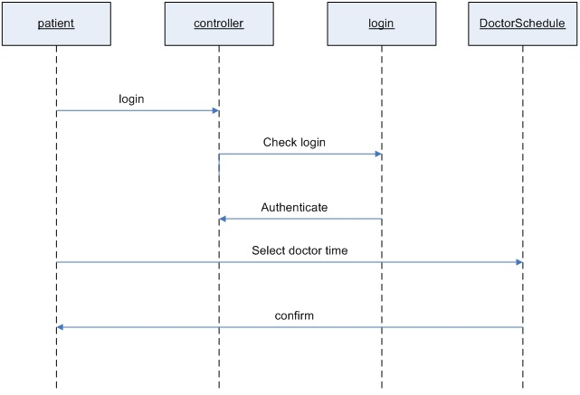

Figure 4 – Sequence Diagram

**Implementation**

1. **Requirement Analysis:**

* Review and analyse the requirements gathered during the design phase, focusing on features such as appointment scheduling, patient registration, and doctor management.
* Break down the requirements into detailed functional specifications, considering the needs of patients, doctors, and administrators.
* Define user stories or use cases to capture the desired functionality from the perspective of different users involved in the appointment process.

1. **Technology Stack Selection:**

* Choose appropriate technologies and frameworks suited for building a robust and scalable Doctor Appointment System.
* Consider using PHP for backend development with frameworks like Laravel for rapid development and robust security features.
* Opt for JavaScript frameworks such as React.js or Vue.js for frontend development to create dynamic and responsive user interfaces.
* Select a relational database management system (RDBMS) like MySQL or PostgreSQL for data storage, ensuring data integrity and scalability.

1. **Database Design:**

* Design a relational database schema that includes tables for patients, doctors, appointments, and other relevant entities.
* Normalize the database structure to eliminate redundancy and ensure efficient data storage and retrieval.
* Define relationships between tables to establish associations between patients, doctors, and appointments.

1. **Backend Development:**

* Set up the backend infrastructure using PHP and the Laravel framework.
* Implement authentication and authorization mechanisms using Laravel's built-in features or third-party packages to secure access to the system.
* Develop RESTful API endpoints to handle CRUD operations for managing appointments, users, and other entities.
* Implement business logic for appointment scheduling, confirmation, cancellation, and notification functionalities.
* Integrate with external services such as email or SMS gateways for appointment reminders and notifications.

1. **Frontend Development:**

* Design user interfaces (UI) for patient appointment scheduling, doctor appointment management, and administrator dashboards.
* Develop responsive and intuitive frontend components using JavaScript frameworks.
* Implement features for appointment search, filtering, and real-time updates to enhance user experience.
* Ensure accessibility and usability by following best practices for frontend development and design.

1. **Integration and Testing:**

* Integrate backend and frontend components to create a seamless user experience.
* Perform unit testing to validate the functionality of individual backend functions and frontend components.
* Conduct integration testing to ensure proper communication between backend APIs and frontend interfaces.
* Perform end-to-end testing to simulate user interactions and verify system behavior in a test environment.
* Use automated testing tools and frameworks to streamline the testing process and identify any bugs or issues.

1. **Deployment and Release:**

* Deploy the system to a staging or testing environment for final validation and user acceptance testing (UAT).
* Prepare deployment scripts and configurations for production deployment.
* Deploy the system to production servers or cloud platforms using automated deployment tools such as Jenkins or Docker.
* Monitor system performance, stability, and user feedback during the initial release phase to identify and address any issues promptly.

1. **Maintenance and Support:**

* Establish procedures for ongoing maintenance, monitoring, and support to ensure the system's reliability and availability.
* Set up logging, monitoring, and alerting systems to track system performance and detect any anomalies or errors.
* Provide user support and troubleshooting assistance through helpdesk systems, documentation, and training materials.
* Regularly update and patch the system to address security vulnerabilities, performance issues, and user feedback.
* Continuously gather user feedback and iterate on the system to improve usability, functionality, and user satisfaction over time.

**Testing Procedure**

Testing procedures are essential to ensure the reliability, functionality, and performance of the Doctor Appointment System. Here are the testing procedures that can be employed:

1. **Unit Testing:**
   * We will perform unit tests on individual components of the system, including backend PHP code and frontend JavaScript code.
   * Each function, method, or class will be tested to ensure it behaves correctly and handles various input scenarios appropriately.
   * We will use testing frameworks such as PHPUnit for backend testing and Jest for frontend testing.
2. **Integration Testing:**
   * Integration tests will be conducted to verify the interaction between different modules or components of the system.
   * We will test how backend APIs communicate with frontend interfaces and ensure that data is transferred accurately.
   * Validation of seamless interaction and data flow between system components will be a priority.
3. **End-to-End Testing:**
   * We will simulate real-world user scenarios through end-to-end tests to validate the system's behavior from start to finish.
   * Testing common user journeys such as appointment scheduling, cancellation, and viewing details will be emphasized.
   * Automated testing tools like Selenium or Cypress will be utilized to mimic user interactions and validate UI functionalities.
4. **Regression Testing:**
   * Regression tests will be conducted to ensure that new code changes do not introduce unintended side effects or break existing functionalities.
   * Existing test cases will be re-run after each code change to confirm that previously implemented features still function correctly.
   * Version control systems like Git will facilitate tracking changes and rollback if regressions occur.
5. **Performance Testing:**
   * We will assess the system's performance under various conditions, including normal usage and peak loads.
   * Measurement of response times, throughput, and resource utilization will help identify performance bottlenecks.
   * Tools such as Apache JMeter or LoadRunner will be used to simulate concurrent user loads and stress test the system.
6. **Security Testing:**
   * Security tests will be conducted to identify vulnerabilities and weaknesses in the system's security mechanisms.
   * Common security threats like SQL injection, cross-site scripting (XSS), and authentication bypass will be tested.
   * Penetration testing tools like OWASP ZAP or Burp Suite will aid in identifying and addressing security vulnerabilities.
7. **Usability Testing:**
   * We will evaluate the system's usability and user experience by gathering feedback from actual users.
   * Usability tests with representative users will help identify any usability issues or areas for improvement.
   * Surveys, interviews, or user observation techniques will be used to collect qualitative feedback on the system's usability.
8. **Accessibility Testing:**
   * Accessibility testing will ensure that the system is usable by users with disabilities, in compliance with accessibility standards such as WCAG.
   * UI components will be tested for navigability, operability, and understandability for users with diverse needs.
   * Automated accessibility testing tools like axe or Wave will be used to identify and rectify accessibility issues.

**System Architecture**

The system architecture of the Doctor Appointment System defines the overall structure, components, and interactions within the software application. It outlines how different modules and layers of the system are organized and how they communicate with each other to achieve the system's objectives. Here's an overview of the system architecture for the Doctor Appointment System :

1. **Client-Side Architecture:**
   * **Presentation Layer (Client):** This layer comprises the user interface components that interact directly with users. It includes web browsers or mobile apps used by patients, doctors, and administrators to access the system.
   * **Client-Side Frameworks:** JavaScript frameworks such as React.js or Vue.js are used to build dynamic and responsive user interfaces. These frameworks handle client-side rendering, user interactions, and data updates.
2. **Server-Side Architecture:**
   * **Application Layer (Server):** The application layer contains the server-side logic responsible for processing requests, executing business logic, and interacting with the database.
   * **Backend Framework:** PHP with the Laravel framework is used for backend development. Laravel provides tools and libraries for routing, middleware, authentication, and database interaction, making it suitable for building robust and scalable web applications.
   * **RESTful API:** The backend exposes RESTful API endpoints to enable communication between the client-side and server-side components. These APIs handle CRUD operations for managing appointments, users, and other entities.
3. **Database Architecture:**
   * **Data Layer (Database):** The data layer stores and manages persistent data used by the application. It typically consists of a relational database management system (RDBMS) such as MySQL or PostgreSQL.
   * **Relational Database Schema:** The database schema includes tables for storing data related to patients, doctors, appointments, and other entities. Relationships between tables are defined to establish associations between different data entities.
4. **Integration Points:**
   * **External Interfaces:** The system may integrate with external systems such as payment gateways, electronic health record (EHR) systems, or third-party APIs for additional functionality.
   * **API Integrations:** Integration points are established using APIs to exchange data and trigger actions between the Doctor Appointment System and external systems.
5. **Infrastructure:**
   * **Hosting Environment:** The system is deployed on a cloud-based hosting platform such as Amazon Web Services (AWS) or Microsoft Azure. The hosting environment provides scalability, reliability, and security for the application.
   * **Server Infrastructure:** Servers are provisioned to run the application backend, database server, and other necessary components. Load balancing and auto-scaling mechanisms are employed to ensure high availability and performance.
6. **Security Architecture:**
   * **Authentication and Authorization:** The system implements authentication mechanisms to verify user identities and authorization rules to control access to resources based on user roles and permissions.
   * **Data Encryption:** Sensitive data such as user credentials and patient information is encrypted to protect confidentiality during transmission and storage.
   * **Security Best Practices:** Security measures such as input validation, parameterized queries, and protection against common web vulnerabilities (e.g., SQL injection, cross-site scripting) are implemented to mitigate security risks.

**Authentication And Authorization**

1. **Authentication:**
   * **User Identification:** When users access the system, they need to prove their identities. This is typically done by providing a username and password combination.
   * **Credential Verification:** The system validates the provided credentials against stored user data to verify the user's identity.
   * **Authentication Methods:** In addition to traditional username-password authentication, the system may support other authentication methods such as biometric authentication (e.g., fingerprint or facial recognition) or two-factor authentication (e.g., SMS verification codes).
2. **Authorization:**
   * **Role-Based Access Control (RBAC):** The system implements role-based access control to determine what actions users are allowed to perform based on their roles within the system. Common roles in the Doctor Appointment System may include:
     + Patient: Can schedule, view, and manage appointments for themselves.
     + Doctor: Can manage appointments, view patient records, and update their availability.
     + Administrator: Has full access to system administration features, including user management and reporting.
   1. **Permission Management:**
      * Patients may have permissions to schedule appointments and view their own appointment history.
      * Doctors may have permissions to manage appointments, view patient records, and update their availability.
      * Administrators may have permissions to manage user accounts, generate reports, and perform administrative tasks.
   * **Access Control Lists (ACLs):** Access control lists are used to enforce permissions at a granular level, specifying which users or roles have access to specific resources or functionalities within the system.
   * **Dynamic Authorization:** Authorization decisions may be dynamic, taking into account factors such as the current state of the system, user context, or specific conditions associated with the requested action.
3. **Session Management:**
   * **Session Creation:** Upon successful authentication, the system creates a session for the user, which is associated with their authenticated identity and authorization context.
   * **Session Persistence:** Sessions are persisted across subsequent requests, allowing users to remain authenticated as they navigate through different pages or perform actions within the system.
   * **Session Expiration:** Sessions have a limited lifespan and may expire after a certain period of inactivity or based on predefined expiration rules to mitigate the risk of session hijacking or unauthorized access.

**Results And Analysis**

1. **Reliability Analysis:**
   * Evaluate the frequency and severity of system failures encountered during testing, focusing on areas such as appointment scheduling, data retrieval, and user authentication.
   * Analyze the impact of any bugs or errors on the overall system reliability and user experience, prioritizing critical issues for resolution.
   * Assess the system's ability to recover from failures and errors gracefully, minimizing disruption to users' appointment scheduling and management processes.
2. **Functionality Analysis:**
   * Review the implementation and performance of key features such as appointment scheduling, appointment management by doctors, and user authentication.
   * Validate that users can successfully schedule appointments, view appointment details, and receive confirmation notifications as expected.
   * Verify that administrative functionalities, such as user management and reporting, are robust and meet the requirements of system administrators.
3. **Performance Analysis:**
   * Analyze performance metrics such as response times for appointment scheduling, appointment confirmation, and data retrieval operations.
   * Evaluate the system's ability to handle concurrent user loads during peak hours, ensuring that performance remains acceptable under varying levels of usage.
   * Identify any scalability limitations or bottlenecks that may affect the system's performance as user traffic increases over time.
4. **Security Analysis:**
   * Review the results of security testing to identify and address vulnerabilities such as SQL injection, cross-site scripting (XSS), and inadequate authentication mechanisms.
   * Ensure that sensitive data, including patient information and login credentials, is adequately protected through encryption and secure transmission protocols.
   * Implement measures to prevent unauthorized access to patient records and appointment data, maintaining the confidentiality and integrity of user information.
5. **Usability Analysis:**
   * Gather feedback from representative users regarding the intuitiveness, ease of use, and overall user experience of the system.
   * Evaluate the effectiveness of user interface (UI) design elements, navigation flows, and interactive features in facilitating users' appointment scheduling and management tasks.
   * Identify any usability issues or pain points reported by users and prioritize enhancements to improve the system's usability and user satisfaction.
6. **Accessibility Analysis:**
   * Review accessibility testing results to ensure that the system is usable by individuals with disabilities, including those using assistive technologies such as screen readers or voice commands.
   * Verify compliance with accessibility standards such as WCAG (Web Content Accessibility Guidelines), addressing any accessibility issues identified during testing.
   * Enhance the accessibility of UI components, forms, and interactive elements to ensure equal access to the system for users of all abilities.

**Conclusion**

In conclusion, the development of the Doctor Appointment System marks a pivotal step forward in addressing the complexities of healthcare scheduling. By combining cutting-edge technology with thoughtful design, we've created a platform that streamlines the appointment process, fosters better communication between patients and healthcare providers, and ultimately improves the overall efficiency of healthcare delivery. Through rigorous testing and continuous refinement, we're confident that our system will make a meaningful impact in enhancing patient care experiences and optimizing healthcare resources.

Looking ahead, our commitment to innovation and responsiveness remains unwavering. As healthcare landscapes evolve and patient needs shift, our system will adapt and grow to meet these challenges head-on. By staying attuned to user feedback and embracing opportunities for improvement, we're poised to deliver even greater value to patients, healthcare professionals, and healthcare organizations alike. In conclusion, the Doctor Appointment System stands as a testament to our dedication to leveraging technology for the betterment of healthcare, and we're excited to continue pushing the boundaries of possibility in this vital field.

**References**

* Codecademy PHP Course (<https://www.codecademy.com/learn/learn-php>)
* Codecademy PHP Course (<https://www.codecademy.com/learn/learn-php>)
* Stack Overflow (https://stackoverflow.com/) for troubleshooting and community support
* BootStrap for Styling (https://getbootstrap.com/)

**Doctor Appointment System : Snapshot**

